Methods | Year | Parameters | Dice | iou | Input size
TransNetR (4) | 2023 | 27.27 | 87.06 | 80.16 | ?
SegMed-Net (8) | 2026 | 59.9 | 90.8 | 83.70 | 352*352
PVT-Cascade (3) | 2023 | 35.2 | 91.1 | 86.3 | 352*352
MegaNet (2) | 2024 | 44.1 | 91.3 | 86.3 | 352*352
Fu-TransHNet (5) | 2023 | ? | 91.6 | 86.6 | 352*352
LiteBoundD (1) | 2026 | 32.8 | 91.9 | 84.1 | 352*352
AAPCNet (7) | 2025 | 38.2 | 92.10 | 86.9 | 256*256
DVFIP-Net | 2026 | 45.62 | 92.20 | 87.40 | 352*352
SAM2-FNet | 2026 | 27.2 | 92.40 | 87.40 | 352*352
MLB-Net | 2026 | 87.7 | 92.60 | 87.80 | 352*352
MSPN | 2026 | 28.56 | 92.70 | 87.90 | 352*352
HCA-Net | 2026 | 89.70 | 93.60 | 89.7 | 352*352
Ours | 2026 | 38.5 | 93.89 | 88.66 | 352*352
PolyMamba-Net (6) | 2026 | 25.3 | 94.2 | 89.1 | 352*352

- Sharpening Lightweight Models for Generalized Polyp Segmentation: A Boundary Guided Distillation from Foundation Models
- “Meganet: Multi-scale edge-guided attention network for weak boundary polyp segmentation
- “Medical image segmentation via cascaded attention decoding
- TransNetR: Transformer-based Residual Network for Polyp Segmentation with Multi-Center Out-of-Distribution Testin
- Cooperation Learning Enhanced Colonic Polyp Segmentation Based on TransformerCNN Fusion
- PolyMamba-Net: a lightweight and boundary-aware network for real-time polyp segmentation in colonoscopy
- Attention-Guided Asymmetric Multiscale Polyp Segmentation Network
- SegMed-Net: a domain-aware dual encoder-decoder network with dense feature fusion for enhanced medical image segmentation

Boundary-Frequency Injection Module:
- Decomposing frequency components
  - Frequency Feature Decomposer (FFD)
  - Spilt skip features into high-frequency and low-frequency using 2D FFT
    - High-frequency -> Boundaries, edges
    - Low-frequency -> semantic content
- Using boundary information for better feature guidance
  - Boundary-guided Squeeze-Excitation Injection (BSEI)
  - Uses Sobel operators to detect boundaries in skip features
  - Creates spatial attention maps from boundary information
  - Uses cross-attention between decoder features and boundary-weighted encoder features

- Adaptively fusing these different feature representations
  - Multi-scale Frequency Adaptive Fusion (MFAF)
  - Learns soft weights to combine high-frequency, low-frequency, and boundary-enhanced features
  - Uses channel-wise gating to decide the importance of each component

Purpose:
The BFIM replaces standard skip connections to:
- Better preserve boundary information during up-sampling
- Adaptively emphasize important frequency components
- Improve segmentation accuracy especially for object boundaries
- Provide learnable fusion instead of simple concatenation

Models | Seen |  |  |  | Unseen |  |  |  |  |  | Epoch
Models | Kvasir-Seg |  | ClinicDB |  | CVC-300 |  | ColonDB |  | ETIS
Models | Dice | iou | Dice | iou | Dice | iou | Dice | iou | Dice | iou
HCA-Net | 93.6 | 89.7 | 95.6 | 90.9 | 91.2 | 87.3 | 83.4 | 76.9 | 83.3 | 78.9
Ours | 92.40 | 86.08 | 95.19 | 90.84 | 91.49 | 84.32 | 81.26 | 70.44 | 87.39 | 77.61 | 1370
Ours-2 | 92.58 | 86.41 | 95.31 | 91.04 |  |  | 81.45 | 70.95 |  |  | 1405
 | 92.03 |  | 95.27 | 90.97 |  |  | 83.34 | 73.75

Models | Seen |  |  |  | Unseen |  |  |  |  |  | Epoch
Models | Kvasir-Seg |  | ClinicDB |  | CVC-300 |  | ColonDB |  | ETIS
Models | Dice | iou | Dice | iou | Dice | iou | Dice | iou | Dice | iou
HCA-Net | 93.6 | 89.7 | 95.6 | 90.9 | 91.2 | 87.3 | 83.4 | 76.9 | 83.3 | 78.9
 | 93.49 | 87.77 | 95.31 | 91.04 | 91.61 | 84.52 | 83.34 | 73.75 | 88.69 | 79.67
Our | 93.49 | 87.77 | 94.92 | 90.33 | 90.33 | 82.52 | 79.72 | 69.16 | 88.69 | 79.67 | 100
Ours | 92.58 | 86.41 | 95.31 | 91.04 | 91.49 | 84.32 | 83.34 | 73.75 | 87.39 | 77.61 | 1370
Ours-93.04 | 92.30 |  |  |  | 91.25 | 83.91 |  |  | 84.96 | 73.85
Ours-93.66 | 92.75 | 86.48 | 95.20 | 90.83 | 91.61 | 84.52 | 82.81 | 72.96 | 85.39 | 74.50 | 2836

Introduction

Related work

Method

Overall architecture

Experiments

Dataset:
To verify the effectiveness of the models, we adopted five public datasets (including Kvasir-SEG [ho-32], CVC-ClinicDB [ho-33], ETIS [ho-34], CVC-ColonDB [ho-35] and CVC-300 [ho-36]) commonly used in existing polyp segmentation studies. These images are acquired from colonoscopy video sequences, and all of them contain the corresponding ground truth. For fair comparison, according to table 1, we split the datasets as in PraNet [8]. The training set consists of 900 images from the Kvasir-SEG and 550 images from the CVC-ClinicDB. The remaining samples in the Kvasir-SEG and the CVC-ClinicDB, and the other three datasets are used as five inde pendent test sets. In this study, we randomly selected 145 images (10 % of the training set) from the training set as the validation set, serving as the criterion for saving the model during training.
Table 1 Number, resolution, and trainin/test split of the five public polyp segmentation datasets. Resized to 352*352.
Dataset | Number | Train | Test | Resolution
Kvasir-Seg | 1000 | 900 | 500 | 500*574
CVC-ClinicDB | 612 | 550 | 62 | 288*384
CVC-ColonDB | 380 | - | 380 | 500*570
ETIS-LaribPolypDB | 196 | - | 196 | 966*1225
CVC-300 | 60 | - | 60 | 500*570

Evaluation metrics

Implementation details
In this work, the proposed ConvNeXt-UNet was trained on a GeForce RTX 3090 GPU with 24 GB memory and a pytorch framework. the AdamW optimizer was employed with a learning rate of 0.0001 and weight decay of 0.0004, and the batch size was set to 16. All samples were resized to 352 ×352 before training. An early stopping mechanism was used to supervise the training. Experiments indicated that the model converged to its optimal state at approximately the 120th epoch.

Comparative study

Quantitative analysis

Qualitative analysis

Models | Seen |  |  |  | Unseen |  |  |  |  |  | Epoch
Models | Kvasir-Seg |  | ClinicDB |  | CVC-300 |  | ColonDB |  | ETIS
Models | Dice | iou | Dice | iou | Dice | iou | Dice | iou | Dice | iou
HCA-Net | 93.6 | 89.7 | 95.6 | 90.9 | 91.2 | 87.3 | 83.4 | 76.9 | 83.3 | 78.9
Our9388 | 93.49 | 87.77 | 94.92 | 90.33 | 90.33 | 82.52 | 79.74 | 69.20 | 88.69 | 79.67 | 100
Ours | 92.58 | 86.41 | 95.31 | 91.04 | 91.49 | 84.32 | 83.34 | 73.75 | 87.39 | 77.61 | 1370
Ours-93.04 | 92.30 |  |  |  | 91.25 | 83.91 |  |  | 84.96 | 73.85
Ours-93.66 | 92.75 | 86.48 | 95.20 | 90.83 | 91.61 | 84.52 | 82.81 | 72.96 | 85.39 | 74.50 | 2836

Table 1 Quantitative comparison of various models on the Kvasir-SEG dataset. The best results are highlighted in bold.
Methods | Year | mDice | mIOU | $$F_{β}^{w}$$ | $$S_{α}$$ | $$mE_{ξ}$$ | $$maxE_{ξ}$$ | MAE
CTNet[20-1] | 2024 | 0.917 | 0.863 | 0.910 | 0.928 | 0.959 | 0.964 | 0.023
MEGANet[47-1] | 2024 | 0.913 | 0.863 | 0.907 | 0.918 | 0.956 | 0.959 | 0.025
CAFÉ-Net[2] | 2024 | 0.933 | 0.889 | 0.927 | 0.939 | 0.967 | ? | 0.019
Polyp-LVT[2] | 2024 | 0.909 | 0.851 | 0.913 | 0.922 | 0.941 | ? | 0.024
Polyp-Mamba[48-1] | 2025 | 0.919 | 0.867 | 0.912 | 0.951 | - | 0.968 | 0.021
MEIN[25-1] | 2025 | 0.905 | 0.847 | 0.905 | 0.914 | - | 0.964 | 0.026
MF-Net[2] | 2025 | 0.915 | 0.863 | 0.939 | 0.924 | 0.962 | ? | 0.022
MSBP-Net[2] | 2025 | 0.919 | 0.868 | 0.916 | 0.926 | 0.961 | ? | 0.023
CIFFormer[2] | 2025 | 0.926 | 0.876 | 0.929 | 0.939 | 0.967 | ? | 0.019
PFPRNet[2] | 2025 | 0.930 | 0.881 | 0.920 | 0.935 | 0.971 | ? | 0.019
PraNet-V2[11-3] | 2025 | 0.907 | 0.853 | ? | ? | ? | ? | 0.025
MLB-Net[1] | 2026 | 0.926 | 0.878 | 0.921 | 0.938 | 0.969 | 0.975 | 0.021
MSPN[3] | 2026 | 0.927 | 0.879 | ? | ? | ? | ? | 0.021
DVFIP-Net[4] | 2026 | 0.922 | 0.874 | ? | ? | ? | ? | ?
Ours | - | 0.935 | 0.879 | 0.901 | 0.935 | 0.952 | 0.963 | 0.025

Table 2 Quantitative comparison of various models on the CVC-ClinicDB dataset. The best results are highlighted in bold.
Methods | Year | mDice | mIOU | $$F_{β}^{w}$$ | $$S_{α}$$ | $$mE_{ξ}$$ | $$maxE_{ξ}$$ | MAE
CTNet[20-1] | 2024 | 0.936 | 0.887 | 0.934 | 0.952 | 0.983 | 0.986 | 0.006
MEGANet[47-1] | 2024 | 0.938 | 0.894 | 0.940 | 0.950 | - | 0.987 | 0.007
Polyp-Mamba[48-1] | 2025 | 0.941 | 0.896 | 0.936 | 0.970 | - | 0.970 | 0.008
MEIN[25-1] | 2025 | 0.923 | 0.878 | 0.928 | 0.944 | - | 0.970 | 0.008
MF-Net[2] | 2025 | 0.931 | 0.884 | 0.953 | 0.949 | 0.983 | ? | 0.006
MSBP-Net[2] | 2025 | 0.940 | 0.892 | 0.927 | 0.939 | 0.976 | ? | 0.007
CIFFormer[2] | 2025 | 0.944 | 0.897 | 0.941 | 0.934 | 0.972 | ? | 0.007
PFPRNet[2] | 2025 | 0.949 | 0.903 | 0.947 | 0.957 | 0.989 | ? | 0.006
PraNet-V2[11-3] | 2025 | 0.929 | 0.88 | ? | ? | ? | ? | 0.009
MLB-Net[1] | 2026 | 0.945 | 0.902 | 0.948 | 0.958 | 0.989 | 0.992 | 0.006
MSPN[3] | 2026 | 0.943 | 0.902 | ? | ? | ? | ? | 0.006
DVFIP-Net[4] | 2026 | 0.942 | 0.896 | ? | ? | ? | ? | ?
Ours | - | 0.951 | 0.906 | 0.931 | 0.954 | 0.983 | 0.990 | 0.009

Table 3 Quantitative comparison of various models on the ETIS-LaribPolypDB dataset. The best results are highlighted in bold.
Methods | Year | mDice | mIOU | $$F_{β}^{w}$$ | $$S_{α}$$ | $$mE_{ξ}$$ | $$maxE_{ξ}$$ | MAE
CTNet[20-1] | 2024 | 0.810 | 0.734 | 0.776 | 0.886 | 0.913 | 0.921 | 0.014
MEGANet[47-1] | 2024 | 0.789 | 0.709 | 0.753 | 0.866 | 0.855 | 0.915 | 0.015
Polyp-Mamba[48-1] | 2025 | 0.756 | 0.668 | 0.756 | 0.887 | - | 0.872 | 0.014
MEIN[25-1] | 2025 | 0.788 | 0.711 | 0.764 | 0.870 | - | 0.902 | 0.018
MF-Net[2] | 2025 | 0.821 | 0.750 | 0.850 | 0.901 | 0.925 | ? | 0.011
MSBP-Net[2] | 2025 | 0.795 | 0.718 | 0.770 | 0.873 | 0.899 | ? | 0.019
CIFFormer[2] | 2025 | 0.810 | 0.746 | 0.858 | 0.889 | 0.918 | ? | 0.013
PFPRNet[2] | 2025 | 0.828 | 0.764 | 0.839 | 0.908 | 0.935 | ? | 0.012
PraNet-V2[11-3] | 2025 | 0.713 | 0.633 | ? | ? | ? | ? | 0.021
MLB-Net[1] | 2026 | 0.821 | 0.744 | 0.780 | 0.899 | 0.914 | 0.935 | 0.013
MSPN[3] | 2026 | 0.798 | 0.717 | ? | ? | ? | ? | 0.017
DVFIP-Net[4] | 2026 | 0.811 | 0.730 | ? | ? | ? | ? | ?
Ours | - | 0.887 | 0.797 | 0.730 | 0.873 | 0.883 | 0.913 | 0.014

Table 4 Quantitative comparison of various models on the CVC-ColonDB dataset. The best results are highlighted in bold.
Methods | Year | mDice | mIOU | $$F_{β}^{w}$$ | $$S_{α}$$ | $$mE_{ξ}$$ | $$maxE_{ξ}$$ | MAE
CTNet[20-1] | 2024 | 0.813 | 0.734 | 0.801 | 0.874 | 0.915 | 0.919 | 0.040
MEGANet[47-1] | 2024 | 0.793 | 0.714 | 0.779 | 0.854 | 0.892 | 0.895 | 0.034
Polyp-Mamba[48-1] | 2025 | 0.791 | 0.713 | 0.765 | 0.846 | - | 0.902 | 0.034
MEIN[25-1] | 2025 | 0.791 | 0.715 | 0.785 | 0.856 | - | 0.897 | 0.034
MF-Net[2] | 2025 | 0.825 | 0.751 | 0.864 | 0.887 | 0.929 | ? | 0.024
MSBP-Net[2] | 2025 | 0.810 | 0.731 | 0.810 | 0.861 | 0.912 | ? | 0.029
CIFFormer[2] | 2025 | 0.823 | 0.741 | 0.851 | 0.874 | 0.918 | ? | 0.026
PFPRNet[2] | 2025 | 0.819 | 0.741 | 0.843 | 0.882 | 0.915 | ? | 0.028
PraNet-V2[11-3] | 2025 | 0.702 | 0.620 | ? | ? | ? | ? | 0.044
MLB-Net[1] | 2026 | 0.832 | 0.757 | 0.825 | 0.886 | 0.924 | 0.931 | 0.023
MSPN[3] | 2026 | 0.811 | 0.734 | ? | ? | ? | ? | 0.029
DVFIP-Net[4] | 2026 | 0.826 | 0.746 | ? | ? | ? | ? | ?
Ours | - | 79.74 | 69.20 | 0.759 | 0.869 | 0.885 | 0.903 | 0.035

Table 5 Quantitative comparison of various models on the CVC-300(Endoscene) dataset. The best results are highlighted in bold.
Methods | Year | mDice | mIOU | $$F_{β}^{w}$$ | $$S_{α}$$ | $$mE_{ξ}$$ | $$maxE_{ξ}$$ | MAE
CTNet[20-1] | 2024 | 0.908 | 0.844 | 0.894 | 0.975 | 0.975 | 0.982 | 0.006
MEGANet[47-1] | 2024 | 0.899 | 0.834 | 0.882 | 0.935 | 0.966 | 0.969 | 0.007
Polyp-Mamba[48-1] | 2025 | 0.906 | 0.840 | 0.888 | 0.936 | - | 0.975 | 0.006
MEIN[25-1] | 2025 | 0.893 | 0.828 | 0.880 | 0.930 | - | 0.965 | 0.007
MF-Net[2] | 2025 | 0.897 | 0.836 | 0.918 | 0.941 | 0.966 | ? | 0.007
MSBP-Net[2] | 2025 | 0.903 | 0.859 | 0.927 | 0.942 | 0.967 | ? | 0.019
CIFFormer[2] | 2025 | 0.883 | 0.822 | 0.912 | 0.939 | 0.961 | ? | 0.10
PFPRNet[2] | 2025 | 0.891 | 0.833 | 0.917 | 0.928 | 0.950 | ? | 0.013
PraNet-V2[11-3] | 2025 | 0.873 | 0.795 |  |  |  |  | 0.007
MLB-Net[1] | 2026 | 0.915 | 0.852 | 0.909 | 0.974 | 0.974 | 0.978 | 0.005
MSPN[3] | 2026 | 0.907 | 0.840 |  |  |  |  | 0.006
DVFIP-Net[4] | 2026 | 0.900 | 0.833 | ? | ? | ? | ? | ?
Ours | - | 0.916 | 0.845 | 0.848 | 0.939 | 0.951 | 0.969 | 0.007

Ablation Studies
To systematically evaluate the individual contributions of the proposed modules to the overall segmentation performance, a comprehensive ablation study was conducted. We define our baseline model as the ConvNeXt-Tiny encoder paired with a lightweight decoder and the final prediction head, completely omitting the Multi-Scale Context (MSC) module, BSEI, the Detail Branch (DB), Gated Detail Fusion (GDF), and Deep Supervision (DS). By incrementally adding or systematically removing these components, we isolated their specific impacts on the network. The quantitative results of these architectural modifications are summarized in Table XX.

Effectiveness of MSC
The Multi-Scale Context (MSC) module is designed to capture and aggregate multi-scale contextual information, which is critical for handling significant variations in target object sizes. To assess its impact, we compared the baseline model with a configuration integrating the MSC module. As shown in Table XX, the addition of the MSC module effectively enhanced the network's spatial adaptability, yielding an improvement of XX% in mDice and XX% in mIoU on the XX dataset. This confirms the module's capability to enrich feature representations prior to the decoding stage.

Effectiveness of BSEI
The BSEI module is introduced to [describe specific function, e.g., enhance boundary spatial features / integrate edge-level information] during the feature extraction process. In our ablation experiments, removing the BSEI module from the combined network led to a noticeable degradation in segmentation accuracy, particularly in [describe specific area, e.g., complex boundary regions]. Specifically, the performance metrics decreased by XX% in mDice and XX% in mIoU (Table XX). This demonstrates that the BSEI module successfully contributes to [describe specific benefit, e.g., refining target boundaries and reducing false positives].

Effectiveness of DB
The Detail Branch (DB) was specifically developed to preserve high-resolution spatial details that are typically lost as features pass through the deeper, heavily down-sampled stages of the encoder. Discarding the DB in the ablation experiments resulted in overly smoothed predictions and a loss of fine-grained structural delineation. Table XX reveals that incorporating the DB leads to an XX% gain in mDice on the XX dataset, validating its necessity for extracting and maintaining high-fidelity spatial details throughout the network.

Effectiveness of GDF
The Gated Detail Fusion (GDF) module acts as a selective mechanism to optimally combine the high-resolution spatial features from the DB with the high-level semantic features from the main network. To isolate the contribution of this gating mechanism, we replaced the GDF module with a standard feature fusion strategy, utilizing simple concatenation and element-wise addition. The results in Table XX indicate that the GDF module significantly outperforms simple fusion, achieving an XX% improvement in mIoU. This highlights the GDF's effectiveness in filtering out background noise and dynamically emphasizing salient target features during the fusion process.

Effectiveness of DS
Finally, Deep Supervision (DS) is employed during the training phase to facilitate direct gradient flow to intermediate layers, thereby alleviating the vanishing gradient problem and optimizing multi-level feature learning. When DS was omitted from the complete proposed architecture (evaluating only the final prediction head loss), the model exhibited slower convergence and a drop in final segmentation accuracy. As evidenced in Table XX, the inclusion of DS improved the mDice by XX%, ensuring more robust feature optimization and contributing to the superior generalization of the proposed framework.

Table X. Ablation study of the proposed architectural components on the five test sets.
Dataset | Metrics | Model
Dataset | Metrics | Baseline | +MSC | +BSEI | +DB | +GDF | +DS
Dataset | Params(M)
Dataset | GFlops(G)
Kvasir-Seg | mDice $↑$
Kvasir-Seg | mIoU $↑$
Kvasir-Seg | $$F_{β}^{w}↑$$
Kvasir-Seg | $S_{α}$ $↑$
Kvasir-Seg | $mE_{ξ}$ $↑$
Kvasir-Seg | $maxE_{ξ}$ $↑$
Kvasir-Seg | MAE $↓$
CVC-ClinicDB | mDice $↑$
CVC-ClinicDB | mIoU $↑$
CVC-ClinicDB | $$F_{β}^{w}↑$$
CVC-ClinicDB | $S_{α}$ $↑$
CVC-ClinicDB | $mE_{ξ}$ $↑$
CVC-ClinicDB | $maxE_{ξ}$ $↑$
CVC-ClinicDB | MAE $↓$
CVC-ColonDB | mDice $↑$
CVC-ColonDB | mIoU $↑$
CVC-ColonDB | $$F_{β}^{w}↑$$
CVC-ColonDB | $S_{α}$ $↑$
CVC-ColonDB | $mE_{ξ}$ $↑$
CVC-ColonDB | $maxE_{ξ}$ $↑$
CVC-ColonDB | MAE $↓$
CVC-300 | mDice $↑$
CVC-300 | mIoU $↑$
CVC-300 | $$F_{β}^{w}↑$$
CVC-300 | $S_{α}$ $↑$
CVC-300 | $mE_{ξ}$ $↑$
CVC-300 | $maxE_{ξ}$ $↑$
CVC-300 | MAE $↓$
ETIS | mDice $↑$
 | mIoU $↑$
 | $$F_{β}^{w}↑$$
 | $S_{α}$ $↑$
 | $mE_{ξ}$ $↑$
 | $maxE_{ξ}$ $↑$
 | MAE $↓$

Notes. MSC = Multi-Scale Context module; DB = Detail Branch; GDF = Gated Detail Fusion; DS = Deep Supervision. Baseline denotes the ConvNeXt-Tiny encoder with the lightweight decoder and final prediction head, without MSC, BSEI, DB, GDF, or DS.

Discussion

Declaration of competing interest
The authors declare that they have no known competing financial interests or personal relationships that could have appeared to influence the work reported in this paper.

Data availability

References
- MLB-Net
- HCA-Net
- MSPN - FROMCOARSETOFINE:MULTI-STAGEPROGRESSIVENETWORKFORCOLONPOLYP SEGMENTATION

- [20-1] Xiao B, HuJ,LiW,PunCM,BiX.Ctnet:Contrastive transformer network for polyp segmentation. IEEE Transactions on Cybernet ics. 2024;.
- [47-1] Bui NT,HoangDH,NguyenQT,TranMT,LeN.Meganet:Multi scale edge-guided attention network for weak boundary polyp segmentation. In: Proceedings of the IEEE/CVF Winter Confer ence on Applications of Computer Vision; 2024. p. 7985–7994.
- [48-1] Zhu X, Wang W, Zhang C, Wang H. Polyp-Mamba: A Hybrid Multi-Frequency Perception Gated Selection Network for polyp segmentation. Information Fusion. 2025;115:102759.
- [25-1] Kang X, MaZ, Liu K, Li Y, Miao Q. Modeling multi-scale uncer tainty with evidence integration for reliable polyp segmentation. Neural Networks. 2025;p. 107553.
- [11-3] Bo-Cheng Hu, Ge-Peng Ji, Dian Shao, and Deng Ping Fan, “Pranet-v2: Dual-supervised reverse atten tion for medical image segmentation,” arXiv preprint arXiv:2504.10986, 2025. 1, 4
- [25-2] S. Wang, S. Lin, F. Sun, and X. Li, “Multi-feature fusion for accurate polyp segmentation using pyramid visual transformers,” Expert Systems with Applications, vol. 280, p. 127558, 2025.
- [34-2] X.-L. Pan, J.-R. Ding, X. Li, S. Liu, J. Wang, B. Hua, G.-Z. Tang, and C.-H. Zhong, “Msbp-net: A multi-scale boundary prediction network for automated polyp segmentation,” Pattern Recognition, vol. 170, p. 112101, 2026.
- [26-2] C. Xu, L. Lin, B. Wang, and J. Liu, “Cifformer: A contextual information flow guided transformer for colorectal polyp segmentation,” Neurocom puting, p. 130413, 2025.
- [29-2] J. Chu, W. Liu, Q. Tian, and W. Lu, “Pfprnet: A phase-wise feature pyramid with retention network for polyp segmentation,” IEEE Journal of Biomedical and Health Informatics, 2024.
- [ho-32] D. Jha, P.H. Smedsrud, M.A. Riegler, et al., Kvasir-SEG: a segmented polyp dataset, in: 26th International conference on MultiMedia Modeling, 2020, pp. 451–462, https://doi.org/10.1007/978-3-030-37734-2_37.
- [ho-33] J. Bernal, F.J. S´anchez, G. Fern´andez-Esparrach, et al., WM-DOVA maps for accurate polyp highlighting in colonoscopy: validation vs. saliency maps from physicians, Comput. Med. Imaging Graph. 43 (2015) 99–111, https://doi.org/ 10.1016/j.compmedimag.2015.02.007.
- [ho-34] J. Silva, A. Histace, O. Romain, et al., Toward embedded detection of polyps in WCE images for early diagnosis of colorectal cancer, Int J Comput Assist Radiol Surg 9 (2) (2014) 283–293, https://doi.org/10.1007/s11548-013-0926-3.
- [ho-35] N. Tajbakhsh, S.R. Gurudu, J. Liang, Automated polyp detection in colonoscopy videos using shape and context information, IEEE Trans Med Imaging 35 (2) (2016) 630–644, https://doi.org/10.1109/TMI.2015.2487997.
- [ho-36] D. V´azquez, J. Bernal, J.F. S´anchez, et al., A benchmark for endoluminal scene segmentation of colonoscopy images, J Heal. Eng 2017 (2017) 1–9, https://doi. org/10.1155/2017/4037190.

Methods | Year | Param (M) | GFLOPs (G)
CTNet[20-1] | 2024
MEGANet[47-1] | 2024
Polyp-Mamba[48-1] | 2025 | 49.5 | 27.9
MEIN[25-1] | 2025
MF-Net[25-2] | 2025
MSBP-Net[34-2] | 2025 | 25.52 | 12.86
CIFFormer[26-2] | 2025 | 32.44 | 13.14
PFPRNet[29-2] | 2025 | 118.52 | 39.39
PraNet-V2[11-3] | 2025
MLB-Net[1] | 2026 | 87.70
MSPN[3] | 2026 | 28.56 | 13.21
DVFIP-Net[4] | 2026 | 46.62 | 19.37
Ours | - | 29.60 | 14.57

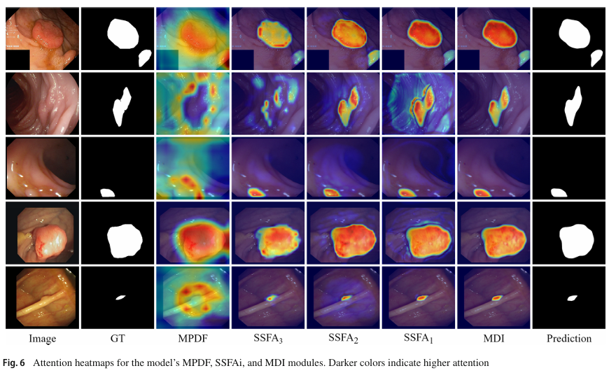
• MultiScaleContext: tests whether multi-scale/global context helps.
• BSEI: tests boundary-aware feature enhancement.
• DetailBranch: tests high-resolution spatial detail recovery.
• GatedDetailFusion: tests whether adaptive fusion is better than simple fusion.

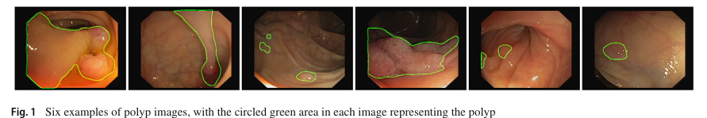

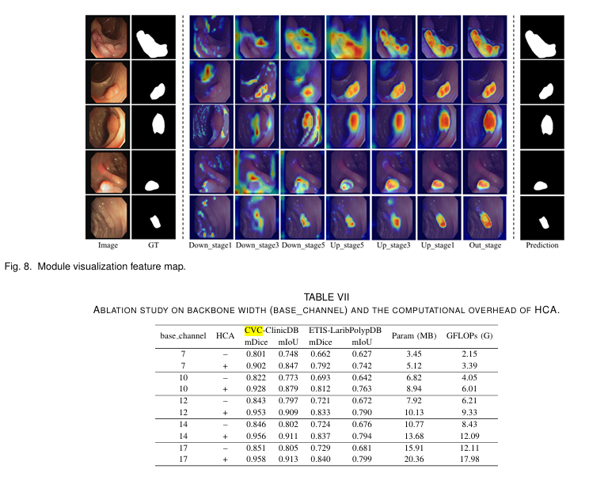

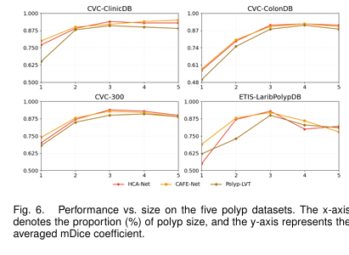

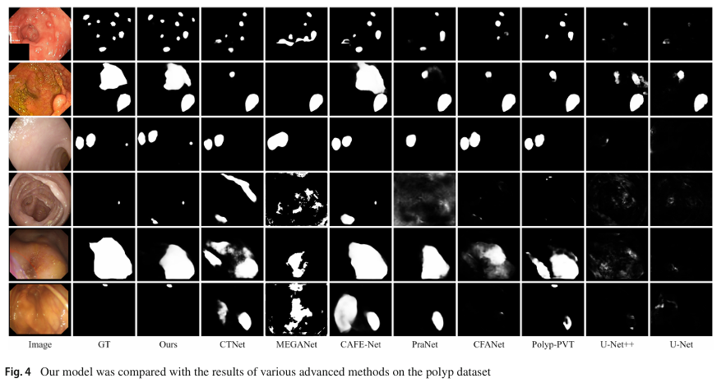

- Image(Diagram) of the model with related Modules -> two images
- Heatmap of the model in ablation study with 6 samples
- Heatmap of the model for some stages
- Heatmap of the model in comparison with other models
- Table of the ablation study

